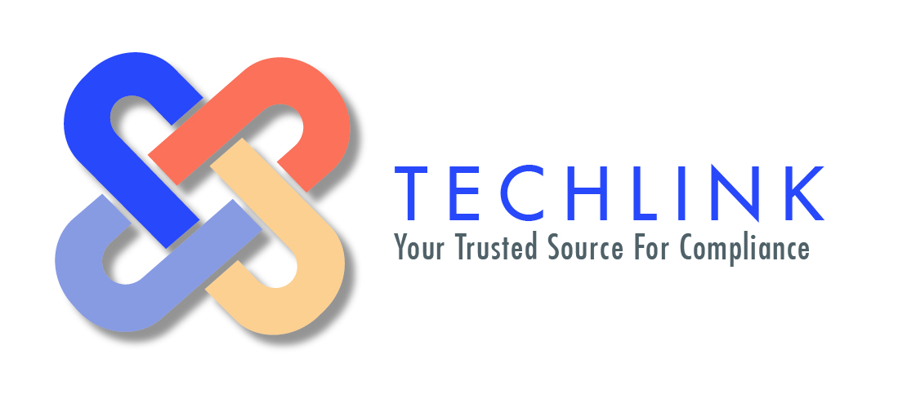

LABEL WORKSHEET FOR NOM-004

Vendor Name: | Brand Name:
Contact: | E-mail: .com
Phone #:
Item Description:  (Only for our internal reference, but not required by law to appear on your textile label, IF THE ITEM IS VISIBLE) | Contents of sell unit:  (Refers to total piece count in final sell unit e.g _ total pieces)
Range of Sizes:  (One-Size-Fits-All, XS, S, M, L, XL, #)  NOTE: Toddler sizes NOT recognized in Mexico  OR  Dimensions:  (LENGTH AND WIDTH in centimeters) –This Applies To Items Like Towels, Blankets, Cushions, Mattresses, Etc.) | Country of Origin of Fabric:  (Where is the fabric from?)  Country of Origin of Product:  (Where is the product made?)  Fabric Breakdown by %  Exterior:  Fill:  Lining (if applicable):
Care instructions need to specify recommended settings for each field below:
Machine Wash:  (Please include with like colors or separate, by hand, dry clean, if applicable)  Water Temperature:  ( Hot, Warm or Cold)  Machine Washing Cycle:  (Delicate or Regular) | Detergent:  (Mild or Regular)  Bleach:  (Reg. Bleach, Whitener w/o Bleach or whether or not Bleach should be used)
Both hand drying and machine drying instructions must be provided:
Machine Drying Instructions:  ( Machine Wash - High, Low, Delicate, etc)  or  Hand Dry Only :  (Only if applicable) | Hand Drying Instructions- Check one for each selection:  1 - Hang to dry or Lay flat  2 - In the sun or In the shade  3 - Wring out or Do not wring out
Ironing:
(Whether or not to use iron & iron settings – warm, hot, cold)

Vendor Name | Date:
---------------------------------------------------------------------------------------------------------------------------------
Vendor Signature (Process will not begin without signature)

